SupersetId-6419073
WEEK 6 – React
1.ReactJS-HOL
(i) Install create-react-app globally:
Command prompt
npm install -g create-react-app
(ii) Create a React App named myfirstreact
npx create-react-app myfirstreact
(iii) Navigate into your project folder
cd myfirstreact
(iv)open project in vscode
Code .

src/App.js
import React from 'react';
function App() {
return (
<div style={styles.container}>
<h1 style={styles.heading}>Welcome to the first session of React</h1>
</div>
);
}
const styles = {
container: {
display: 'flex',
justifyContent: 'center',
alignItems: 'center',
height: '100vh',
backgroundColor: '#f4f4f4',
},
heading: {
color: '#2c3e50',
fontFamily: 'Arial, sans-serif',
},
};
export default App;
(vi) Start the development server
npm start

Open browser and visit:
http://localhost:3000

OUTPUT:
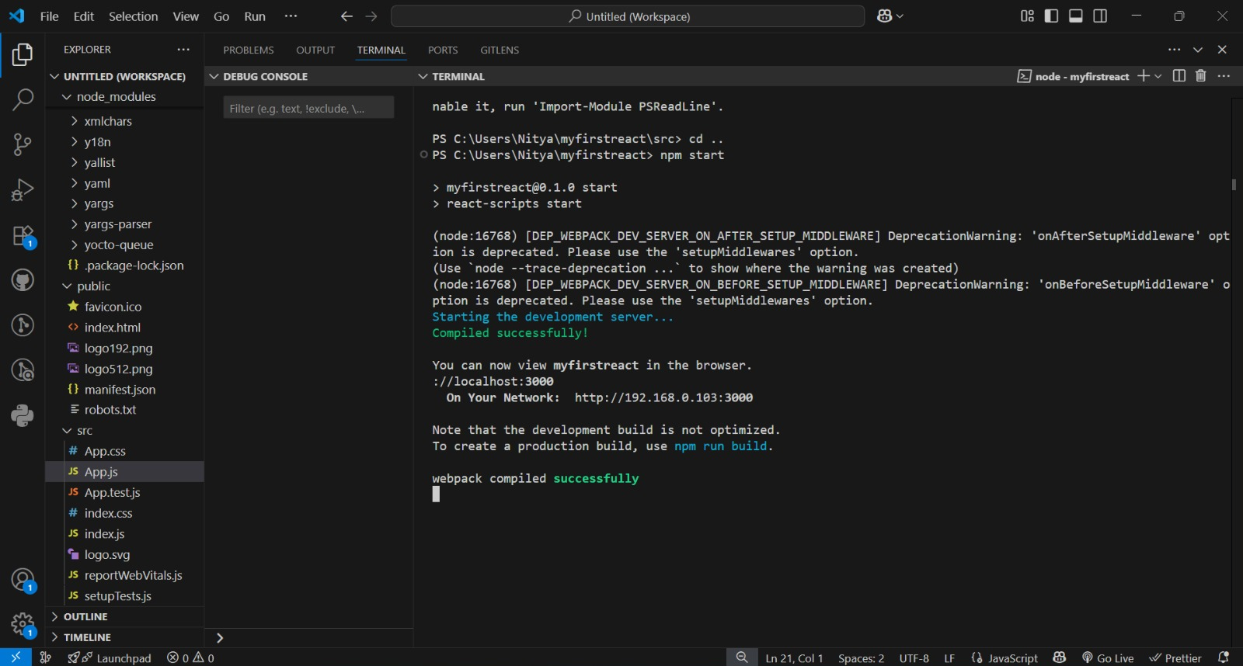
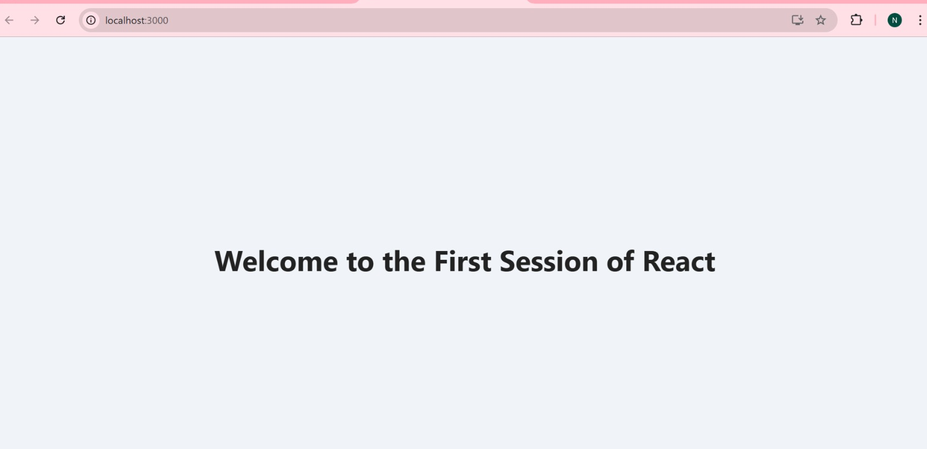
2.ReactJS-HOL
(i)Setting upreact project
npx create-react-app studentapp
cd studentapp
npm start

(ii)Folder structure
src/
├── components/
│ ├── Home.js
│ ├── About.js
│ ├── Contact.js
├── App.js
├── index.js
Home.js
import React from "react";
const Home = () => {
return (
<div style={styles.container}>
<h1>Welcome to the Home page of Student Management Portal</h1>
</div>
);
};
const styles = {
container: {
textAlign: "center",
padding: "2rem",
color: "#2c3e50",
fontFamily: "Arial, sans-serif",
},
};
export default Home;
About.js
import React from "react";
const About = () => {
return (
<div style={styles.container}>
<h1>Welcome to the About page of the Student Management Portal</h1>
</div>
);
};
const styles = {
container: {
textAlign: "center",
padding: "2rem",
color: "#16a085",
fontFamily: "Arial, sans-serif",
},
};
export default About;
Contact.js
import React from "react";
const Contact = () => {
return (
<div style={styles.container}>
<h1>Welcome to the Contact page of the Student Management Portal</h1>
</div>
);
};
const styles = {
container: {
textAlign: "center",
padding: "2rem",
color: "#8e44ad",
fontFamily: "Arial, sans-serif",
},
};
export default Contact;
App.js
import React from "react";
import { BrowserRouter as Router, Routes, Route, Link } from "react-router-dom";
import Home from "./components/Home";
import About from "./components/About";
import Contact from "./components/Contact";
const App = () => {
return (
<Router>
<div style={styles.navbar}>
<Link style={styles.link} to="/">Home</Link>
<Link style={styles.link} to="/about">About</Link>
<Link style={styles.link} to="/contact">Contact</Link>
</div>
<Routes>
<Route path="/" element={<Home />} />
<Route path="/about" element={<About />} />
<Route path="/contact" element={<Contact />} />
</Routes>
</Router>
);
};
const styles = {
navbar: {
display: "flex",
justifyContent: "center",
gap: "1.5rem",
backgroundColor: "#f4f4f4",
padding: "1rem",
},
link: {
textDecoration: "none",
color: "#333",
fontWeight: "bold",
fontSize: "1.1rem",
},
};
export default App;
terminal
npm install react-router-dom
run the app
npm start

OUTPUT:
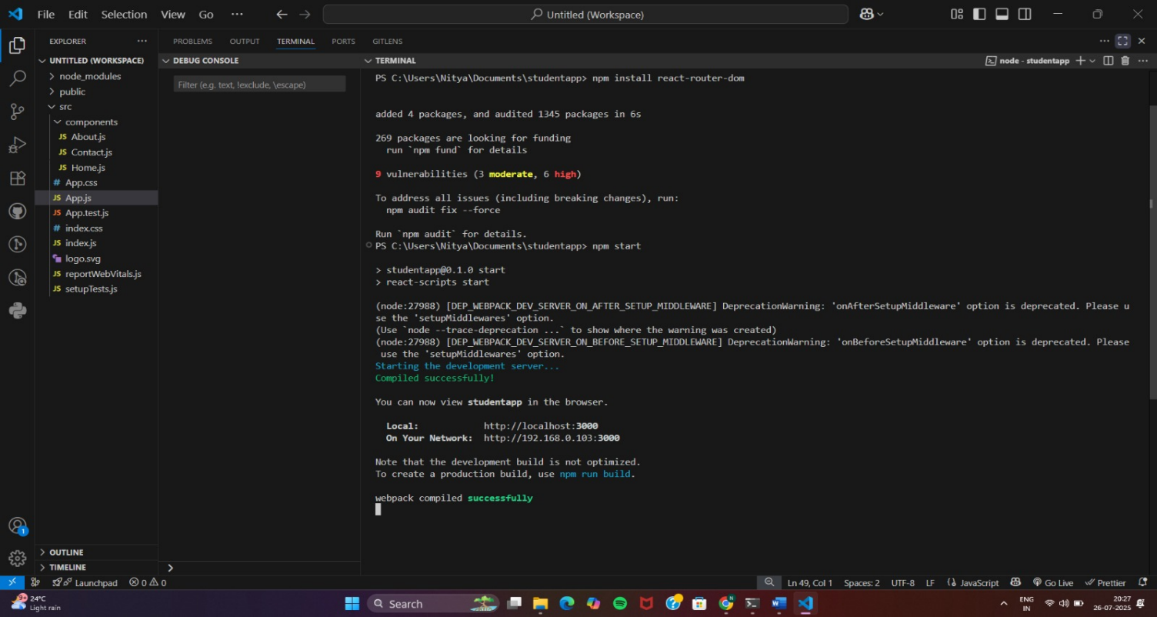
http://localhost:3000
Home page
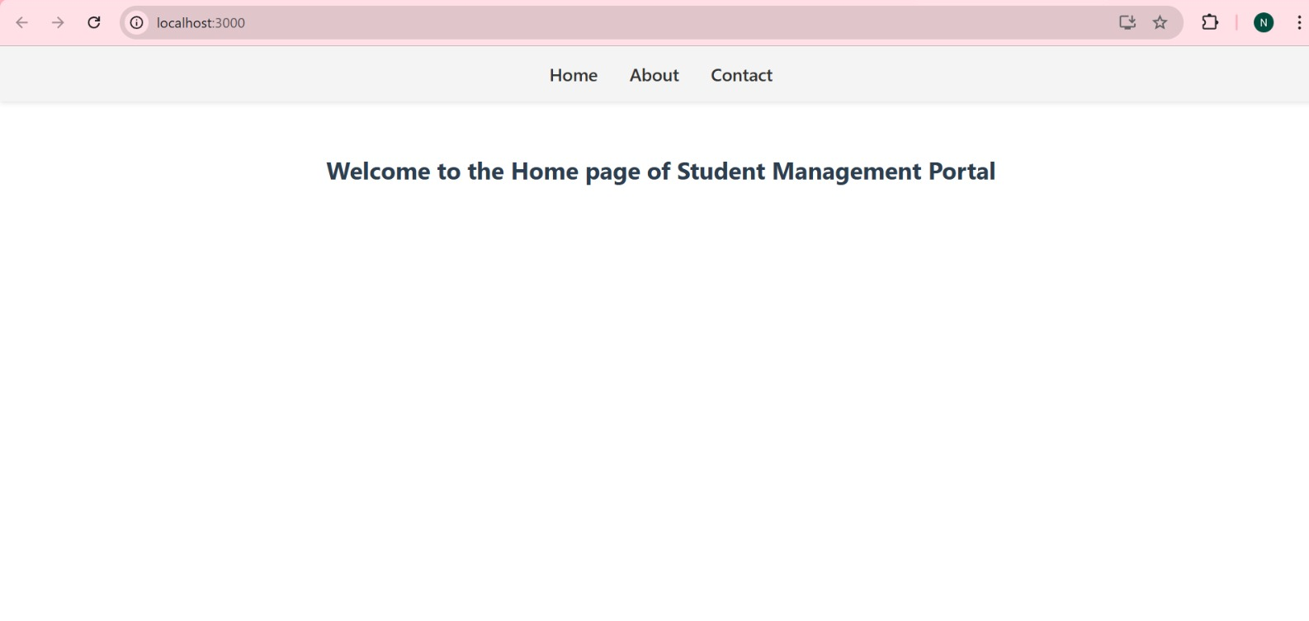
About page
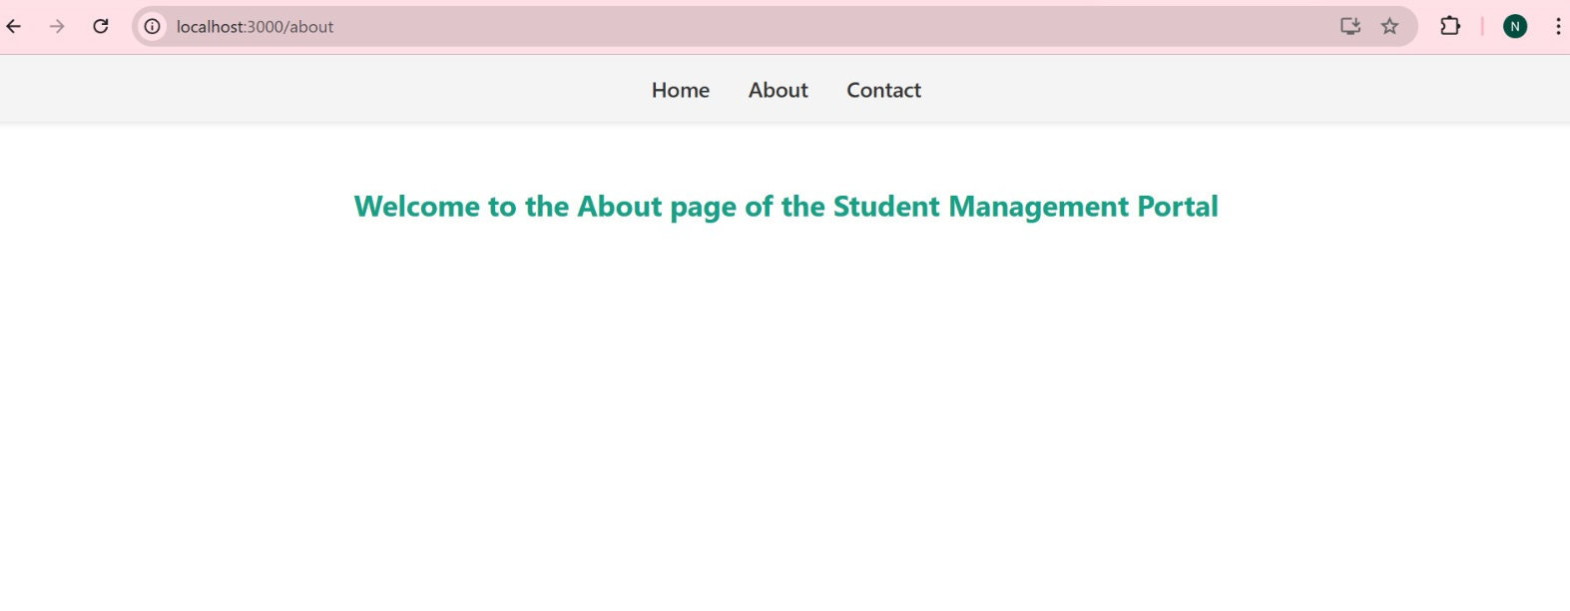
Contact page
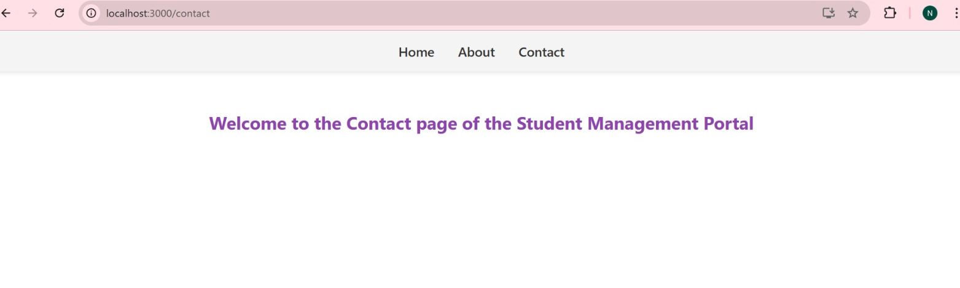
3.ReactJS-HOL
(i)Setting up the project
npx create-react-app scorecalculatorapp
cd scorecalculatorapp

(ii)Folder structure
src/
├── Components/
│ └── CalculateScore.js
├── Stylesheets/
│ └── mystyle.css
└── App.js (edit this)
CalculateScore.js
import React, { useState } from "react";
import "../Stylesheets/mystyle.css";

const CalculateScore = () => {
const [name, setName] = useState("");
const [school, setSchool] = useState("");
const [total, setTotal] = useState("");
const [goal, setGoal] = useState("");
const [average, setAverage] = useState(null);
const handleCalculation = () => {
const totalNum = parseFloat(total) || 0;
const goalNum = parseFloat(goal) || 1;
setAverage((totalNum / goalNum).toFixed(2));
};
return (
<div className="score-container">
<h2>Student Score Calculator</h2>
<input
type="text"
placeholder="Enter Student Name"
value={name}
onChange={(e) => setName(e.target.value)}
/>
<input
type="text"
placeholder="Enter School Name"
value={school}
onChange={(e) => setSchool(e.target.value)}
/>
<input
type="number"
placeholder="Enter Total Score"
value={total}
onChange={(e) => setTotal(e.target.value)}
/>
<input
type="number"
placeholder="Enter Goal (e.g., Total Subjects)"
value={goal}
onChange={(e) => setGoal(e.target.value)}
/>
<button onClick={handleCalculation}>Calculate Average</button>
{average !== null && (
<div className="result">
<h3>Results</h3>
<p><strong>Name:</strong> {name || "N/A"}</p>
<p><strong>School:</strong> {school || "N/A"}</p>
<p><strong>Average Score:</strong> {average}</p>
</div>
)}
</div>
);
};
export default CalculateScore;
mystyle.css
/* src/Stylesheets/mystyle.css */
body {
margin: 0;
font-family: Arial, sans-serif;
background: #f9fafc;
display: flex;
justify-content: center;
align-items: center;
height: 100vh;
}
.score-container {
background: #ffffff;
padding: 2rem;
border-radius: 12px;
box-shadow: 0px 4px 12px rgba(0, 0, 0, 0.1);
max-width: 400px;
text-align: center;
}
.score-container h2 {
color: #333;
margin-bottom: 1rem;
}
input {
width: 100%;
padding: 10px;
margin: 8px 0;
border: 1px solid #ccc;
border-radius: 6px;
}

button {
background: #4cafef;
color: #fff;
padding: 10px 16px;
margin-top: 12px;
border: none;
border-radius: 6px;
cursor: pointer;
transition: background 0.3s ease-in-out;
}
button:hover {
background: #3a9bdc;
}
.result {
margin-top: 20px;
text-align: left;
}
.result h3 {
color: #444;
margin-bottom: 8px;
}

App.js
// src/App.js
import React from "react";
import CalculateScore from "./Components/CalculateScore";
function App() {
return (
<div>
<CalculateScore />
</div>
);
}
export default App;

Run the App
npm start

OUTPUT:
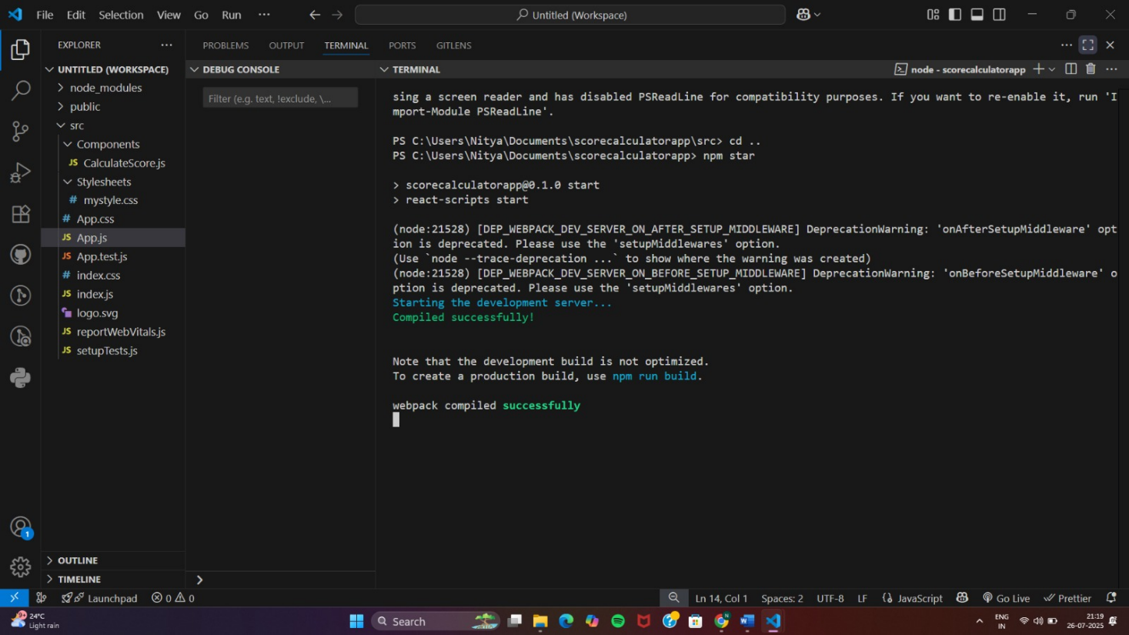
http://localhost:3000
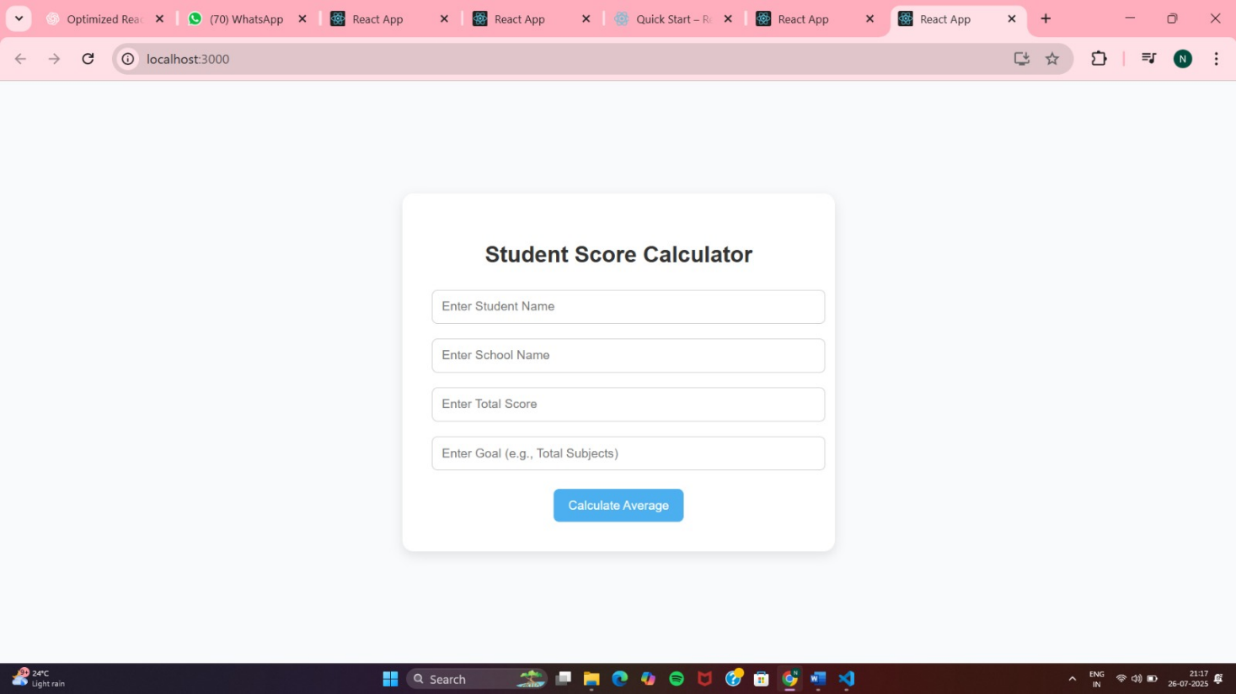

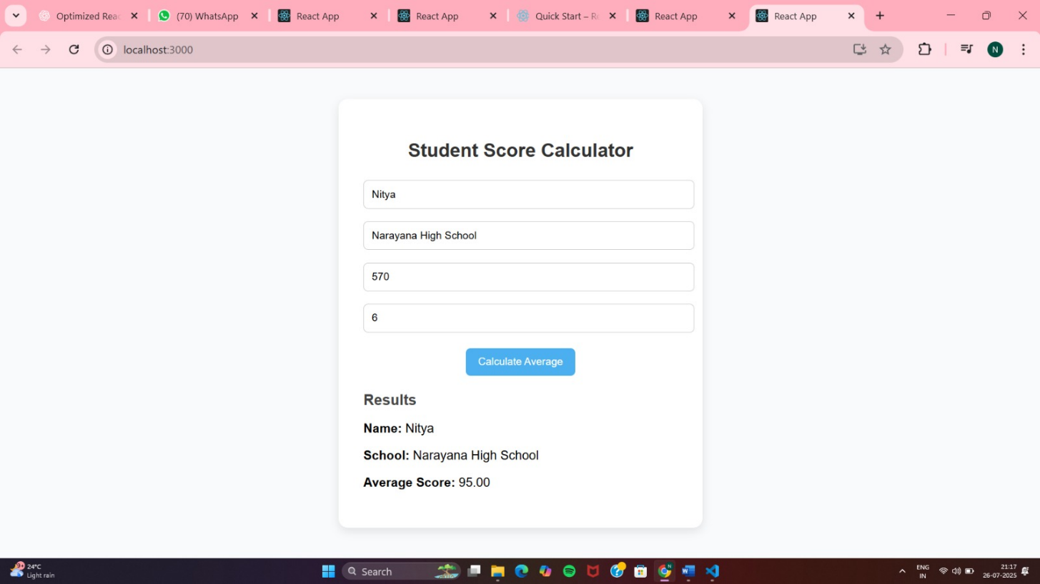

4.ReactJS-HOL
(i)Setting up the project
npx create-react-app blogapp
cd blogapp

(ii)Folder structure
src/
├── Posts.js
├── Post.js
├── Stylesheets/
│ └── mystyle.css
└── App.js

Post.js
import React from "react";
import "./Stylesheets/mystyle.css";
const Post = ({ title, body }) => {
return (
<div className="post-card">
<h2>{title}</h2>
<p>{body}</p>
</div>
);
};
export default Post;

Posts.js
// src/Posts.js
import React, { Component } from "react";
import Post from "./Post";
import "./Stylesheets/mystyle.css";
class Posts extends Component {
constructor(props) {
super(props);
this.state = {
posts: [],
error: null,
loading: true,
};
}
// Fetch posts when the component mounts
componentDidMount() {
this.loadPosts();
}
// Lifecycle method for catching errors
componentDidCatch(error, info) {
console.error("Error occurred:", error, info);
alert("Something went wrong while loading posts.");
this.setState({ error });
}
// Fetch API method to get posts
loadPosts = async () => {
try {
const response = await fetch("https://jsonplaceholder.typicode.com/posts");
if (!response.ok) throw new Error("Failed to fetch posts");
const data = await response.json();
this.setState({ posts: data.slice(0, 10), loading: false }); // Limit to 10 posts
} catch (err) {
this.setState({ error: err.message, loading: false });
}
};
render() {
const { posts, error, loading } = this.state;
if (loading) return <p className="loading">Loading posts...</p>;
if (error) return <p className="error">Error: {error}</p>;
return (
<div className="posts-container">
<h1>Blog Posts</h1>
{posts.map((post) => (
<Post key={post.id} title={post.title} body={post.body} />
))}
</div>
);
}
}export default Posts;
mystyle.css
/* src/Stylesheets/mystyle.css */
body {
margin: 0;
font-family: Arial, sans-serif;
background: #f5f7fa;
display: flex;
justify-content: center;
align-items: flex-start;
min-height: 100vh;
padding: 20px;
}
.posts-container {
width: 90%;
max-width: 800px;
background: #ffffff;
padding: 20px;
border-radius: 12px;
box-shadow: 0px 4px 10px rgba(0, 0, 0, 0.1);
}
.posts-container h1 {
text-align: center;
color: #222;
margin-bottom: 20px;
}
.post-card {
background: #f9fafc;
padding: 15px;
margin: 10px 0;
border-left: 5px solid #4cafef;
border-radius: 8px;
transition: background 0.3s ease-in-out;
}
.post-card:hover {
background: #eef6ff;
}
.post-card h2 {
color: #333;
margin-bottom: 8px;
}
.loading,
.error {
text-align: center;
color: #555;
font-size: 18px;
}
.error {
color: red;
}

App.js
// src/App.js
import React from "react";
import Posts from "./Posts";
function App() {
return (
<div>
<Posts />
</div>
);
}
export default App;
Run the App
npm start

OUTPUT:
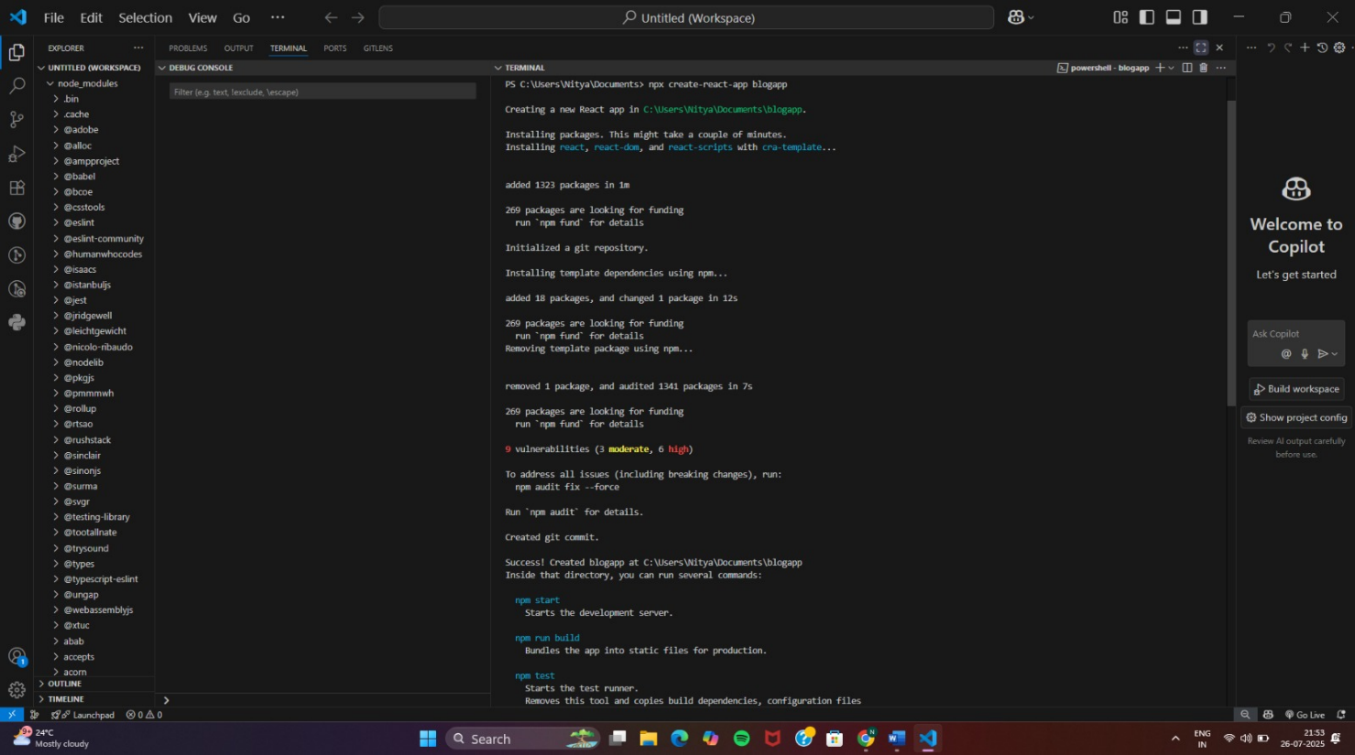
http://localhost:3000
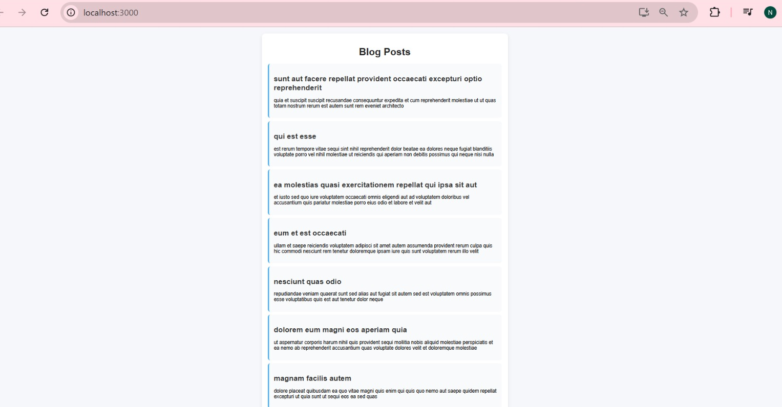
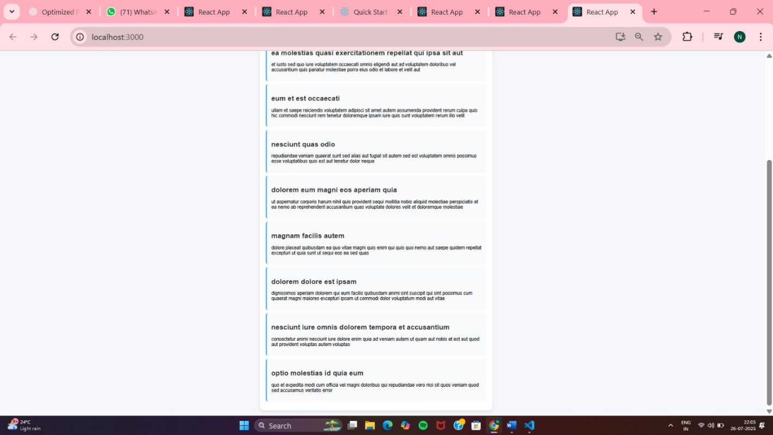
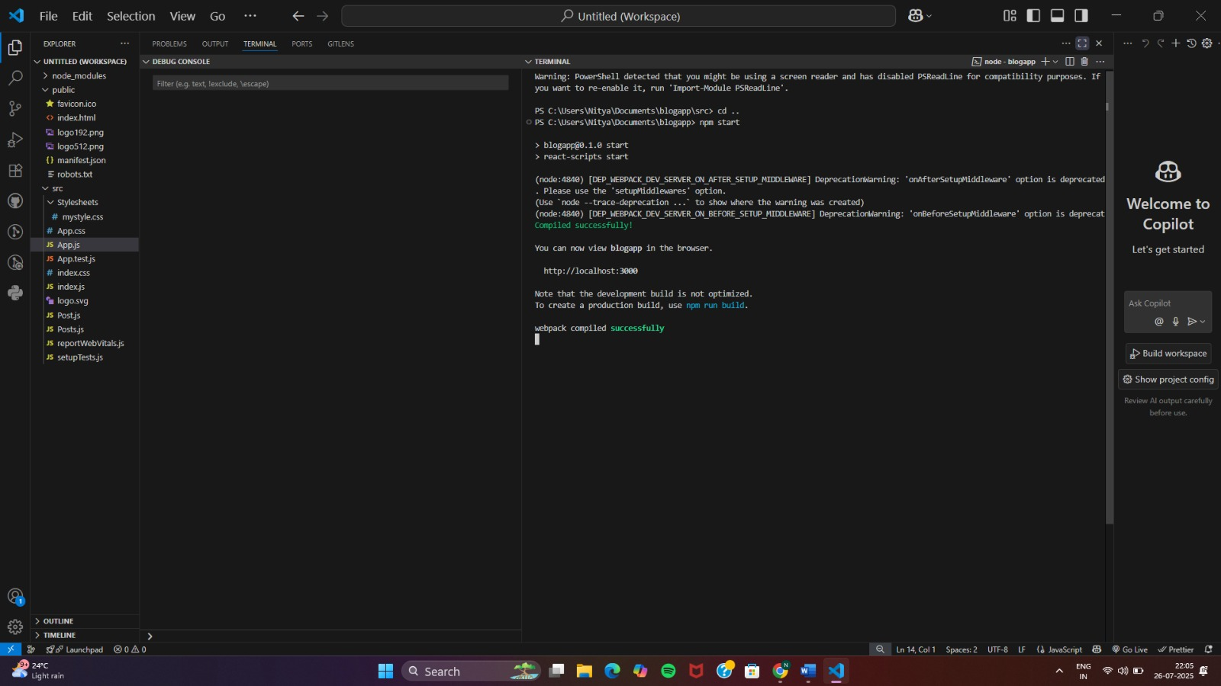

5.ReactJS-HOL
(i)Setting up the project
npx create-react-app cohort-dashboard
cd cohort-dashboard
code .
(ii)Folder structure
src/
├── components/
│ ├── CohortDetails.js
│ └── CohortDetails.module.css
CohortDetails.module.css
.box {
width: 300px;
display: inline-block;
margin: 10px;
padding: 10px 20px;
border: 1px solid black;
border-radius: 10px;
background-color: #fdfdfd;
box-shadow: 0 2px 8px rgba(0, 0, 0, 0.08);
transition: all 0.3s ease-in-out;
}
dt {
font-weight: 500;
}

CohortDetails.js
import React from 'react';
import styles from './CohortDetails.module.css';
function CohortDetails({ name, startDate, endDate, status }) {
const statusColor = status === 'ongoing' ? 'green' : 'blue';
return (
<div className={styles.box}>
<h3 style={{ color: statusColor }}>
{name} ({status.toUpperCase()})
</h3>
<dl>
<dt>Start Date:</dt>
<dd>{startDate}</dd>
<dt>End Date:</dt>
<dd>{endDate}</dd>
</dl>
</div>
);
}
export default CohortDetails;
App.js
import React from 'react';
import CohortDetails from './components/CohortDetails';
function App() {
const cohorts = [
{
name: 'React Bootcamp',
startDate: '2024-11-10',
endDate: '2025-01-15',
status: 'ongoing'
},
{
name: 'Node.js Advanced',
startDate: '2024-09-01',
endDate: '2024-11-05',
status: 'completed'
}
];
return (
<div style={{ padding: '30px' }}>
{cohorts.map((cohort, index) => (
<CohortDetails key={index} {...cohort} />
))}
</div>
);
}
export default App;

Run the App
npm start
OUTPUT:
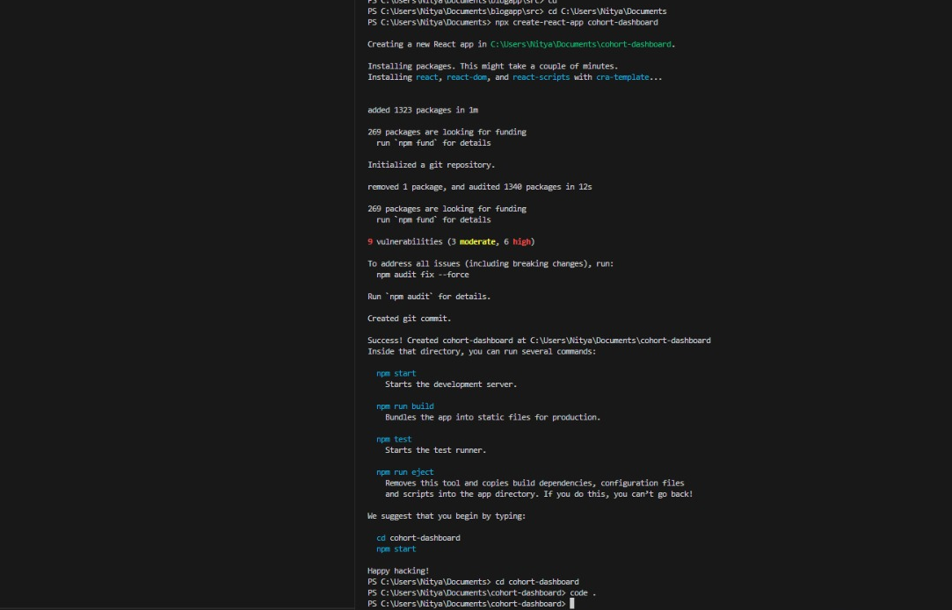
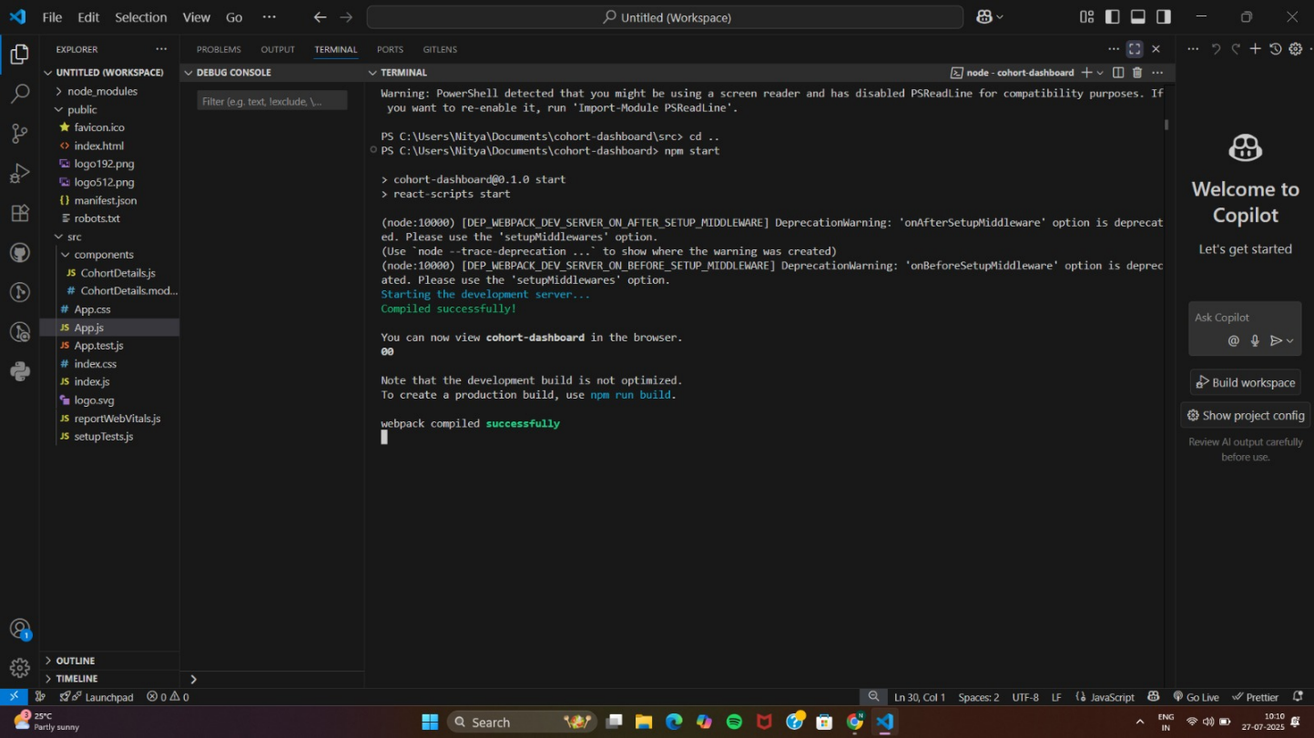
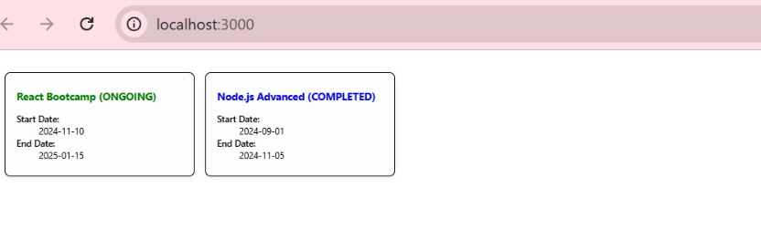

6.ReactJS-HOL
(i)Setting up the project
npx create-react-app trainers-app
cd trainers-app
npm install react-router-dom

src/trainer.js
class Trainer {
constructor(trainerId, name, email, phone, technology, skills) {
this.trainerId = trainerId;
this.name = name;
this.email = email;
this.phone = phone;
this.technology = technology;
this.skills = skills;
}
}
export default Trainer;

src/TrainersMock.js
import Trainer from './trainer';
const trainers = [
new Trainer(1, 'Alice Johnson', 'alice@example.com', '123-456-7890', 'React', ['JSX', 'Hooks', 'Redux']),
new Trainer(2, 'Bob Smith', 'bob@example.com', '234-567-8901', 'Node.js', ['Express', 'MongoDB']),
new Trainer(3, 'Charlie Brown', 'charlie@example.com', '345-678-9012', 'Python', ['Flask', 'Pandas'])
];
export default trainers;
src/Home.js
import React from 'react';
export default function Home() {
return (
<div style={{ padding: '20px' }}>
<h2>Welcome to Cognizant Academy</h2>
<p>This SPA showcases trainers and their technical expertise.</p>
</div>
);
}

src/TrainerList.js
import React from 'react';
import { Link } from 'react-router-dom';
import trainers from './TrainersMock';
export default function TrainerList() {
return (
<div style={{ padding: '20px' }}>
<h2>Trainers List</h2>
<ul>
{trainers.map((trainer) => (
<li key={trainer.trainerId}>
<Link to={`/trainers/${trainer.trainerId}`}>
{trainer.name}
</Link>
</li>
))}
</ul>
</div>
);
}
src/TrainerDetails.js
import React from 'react';
import { useParams } from 'react-router-dom';
import trainers from './TrainersMock';
export default function TrainerDetails() {
const { id } = useParams();
const trainer = trainers.find(t => t.trainerId === parseInt(id));
if (!trainer) return <p>Trainer not found.</p>;
return (
<div style={{ padding: '20px' }}>
<h2>Trainer Details</h2>
<p><strong>Name:</strong> {trainer.name}</p>
<p><strong>Email:</strong> {trainer.email}</p>
<p><strong>Phone:</strong> {trainer.phone}</p>
<p><strong>Technology:</strong> {trainer.technology}</p>
<p><strong>Skills:</strong> {trainer.skills.join(', ')}</p>
</div>
);
}
src/App.js
import React from 'react';
import { BrowserRouter as Router, Routes, Route, Link } from 'react-router-dom';
import Home from './Home';
import TrainerList from './TrainerList';
import TrainerDetails from './TrainerDetails';

function App() {
return (
<Router>
<nav style={{
padding: '10px',
backgroundColor: '#222',
color: '#fff',
display: 'flex',
gap: '20px'
}}>
<Link to="/" style={{ color: '#fff' }}>Home</Link>
<Link to="/trainers" style={{ color: '#fff' }}>Trainers</Link>
</nav>
<Routes>
<Route path="/" element={<Home />} />
<Route path="/trainers" element={<TrainerList />} />
<Route path="/trainers/:id" element={<TrainerDetails />} />
</Routes>
</Router>
);
}
export default App;
Run the App
npm start
OUTPUT:
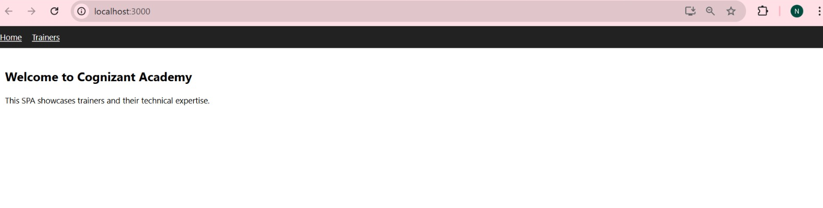
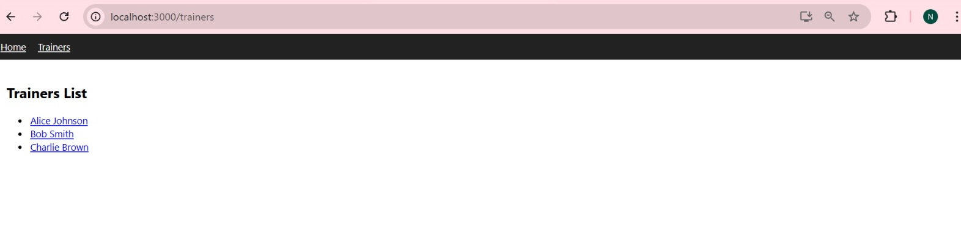
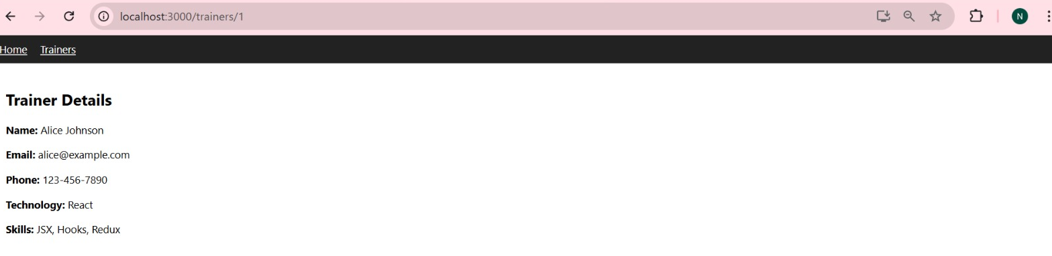
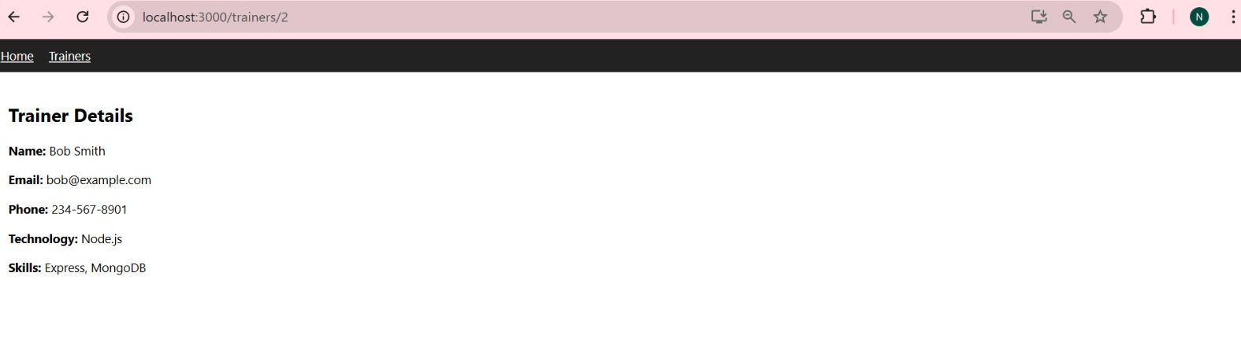
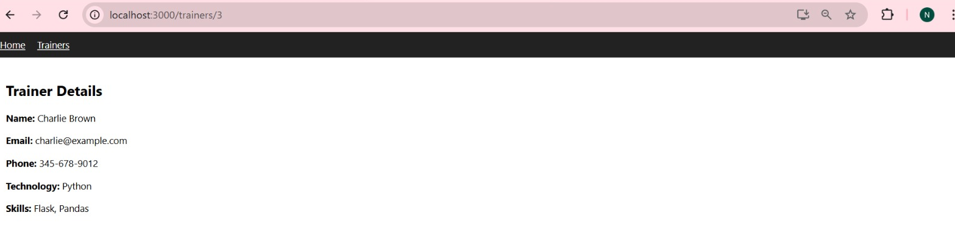
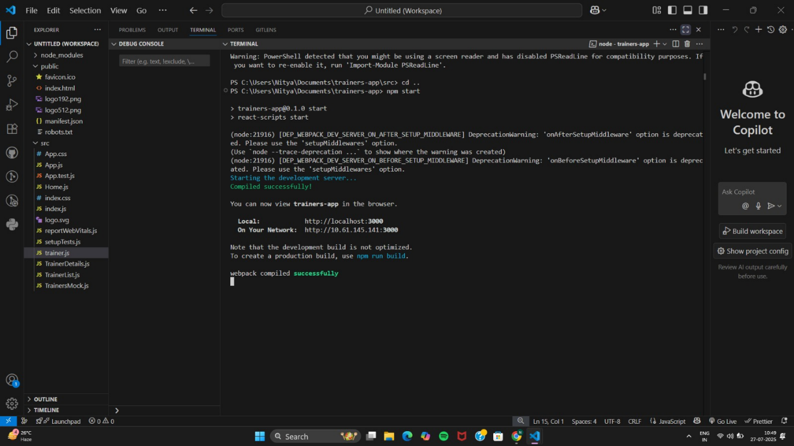
7.ReactJS-HOL
(i)Setting up the project
npx create-react-app shoppingapp
cd shoppingapp
code .

(ii)Folder structure
src/
├── components/
│ ├── Cart.js
│ └── OnlineShopping.js
├── index.js
├── App.js

Cart.js
// src/components/Cart.js
import React, { Component } from 'react';

class Cart extends Component {
static defaultProps = {
itemName: 'Unknown Item',
price: 0
};
render() {
const { itemName, price } = this.props;
return (
<div style={{
border: '1px solid #ccc',
marginBottom: '10px',
padding: '10px',
borderRadius: '6px',
width: '250px'
}}>
<h4>{itemName}</h4>
<p>Price: ₹{price}</p>
</div>
);
}
}
export default Cart;

OnlineShopping.js
// src/components/OnlineShopping.js
import React, { Component } from 'react';
import Cart from './Cart';

class OnlineShopping extends Component {
constructor() {
super();
this.items = [
{ id: 1, itemName: 'Wireless Mouse', price: 599 },
{ id: 2, itemName: 'Bluetooth Speaker', price: 1499 },
{ id: 3, itemName: 'USB-C Hub', price: 899 },
{ id: 4, itemName: 'Smartwatch', price: 2999 },
{ id: 5, itemName: 'LED Lamp', price: 499 }
];
}
render() {
return (
<div style={{ padding: '20px' }}>
<h2>Online Shopping Cart</h2>
{this.items.map(item => (
<Cart key={item.id} itemName={item.itemName} price={item.price} />
))}
</div>
);
}
}
export default OnlineShopping;

index.js
// src/index.js
import React from 'react';
import ReactDOM from 'react-dom/client';
import OnlineShopping from './components/OnlineShopping';

const root = ReactDOM.createRoot(document.getElementById('root'));
root.render(<OnlineShopping />);

Run the App
npm start
OUTPUT:
